

Hyderabad

**A Project Report on**

**GAME STORE APPLICATION**

By

Teja Sai Dhondu

CERTIFICATE



Certified that this is Project work done by Ms./Mr. TEJA SAI DHONDU of Class XII, Roll No……………………. in the Informatics Practices Department of Oakridge International School for the year 2016-2017.

**Lecturer in Charge**

Dept. of Informatics Practices.

Signature of External Examiner

Examiner Code:

ACKNOWLEDGEMENT

We are extremely grateful to our informatics practices teacher **Mr. Mirza Asjad Baig** for his invaluable support and guidance. We are grateful for his extended services not only in the course of this project, but also throughout the academic year of 2016-2017

Under his guidance, we have successfully completed this project as a practical fulfillment for the completion of the course well within the stipulated period of time.

We are also thankful to our co-ordinator **Ms. Anuradha Vanta**

**Front End Application Software**





**Back-End Data base**

*AIM*

The purpose of the project is to create an application that provides information about all the games in a Video Game store. We can easily view all the information of the games and platforms in stock in the game store. Ability to search records based on different selection criteria is supported. There is support for two different users. User “chairman” is the power user. Ability to add records, update records and delete records is provided for the power user “chairman”.

**ABSTRACT**

This tool requires an RDBMS, which is used to store the information and MySQL is the preferred software for maintaining the data. It maintains the information in the table form so that it can be accessed easily.

In this client side we will be using Java Net beans 8.1 providing the user interface. The requests of the client are made in the interface, which connect to the tables created in MySQL for getting the current information

**The basic structure and contents of the tables are as follows:**

**drop database ipproject;**

**create database ipproject;**

**use ipproject;**

**create table login**

**(username varchar(20) primary key,**

**password varchar(20));**

**insert into login values**

**("bilal","bilal"),**

**("chairman","chairman"),**

**("drake","drake"),**

**("guest","guest"),**

**("teja","teja");**

**create table platforms**

**(Platform_Type varchar(30) primary key,**

**Xbox_One char(1),**

**PS4 char(1),**

**PC chair(1));**

**insert into platforms values**

**("ALL","Y","Y","Y"),**

**("PCE","N","N","Y"),**

**("PSE","N","Y","N"),**

**("PSPC","N","Y","Y"),**

**("XBE","Y","N","N"),**

**("XBPC","Y","N","Y"),**

**("XBPS","Y","Y","N");**

**create table games**

**(Sno int primary key,**

**Game_Name varchar(30),**

**Studio varchar(30),**

**Genre varchar(30),**

**Release_Year int,**

**Price int,**

**Platform_Type varchar(30),**

**foreign key(Platform_Type) references platforms(Platform_Type)**

**on delete cascade**

**on update cascade);**

**insert into games values**

**(101,"Bloodborne","From Software","Role Playing Game",2015,2100,"PSE"),**

**(102,"Demon's Souls","From Software","Role Playing Game",2009,1000,"PSE"),**

**(103,"Dark Souls III","From Software","Role Playing Game",2016,2600,"XBPC"),**

**(104,"Dark Souls II","From Software","Role Playing Game",2014,1400,"ALL"),**

**(105,"Uncharted 4","Naughty Dog","Action Adventure",2016,2600,"XBPS"),**

**(106,"Uncharted 3","Naughty Dog","Action Adventure",2013,1000,"PSE"),**

**(107,"Uncharted 2","Naughty Dog","Action Adventure",2009,500,"PSE"),**

**(108,"Uncharted","Naughty Dog","Action Adventure",2007,500,"PSE"),**

**(109,"Dark Souls","From Software","Role Playing Game",2010,1000,"PSPC"),**

**(110,"Halo 5","343 Industries","First Person Shooter",2015,3000,"XBE"),**

**(111,"Call of Duty Advanced Warfare","Activision","First Person Shooter",2014,2000,"ALL"),**

**(112,"Call of Duty Infinite Warfare","Activision","First Person Shooter",2016,4000,"PSPC"),**

**(113,"Call of Duty Black Ops 3","Activision","First Person Shooter",2015,3000,"ALL"),**

**(114,"Call of Ghosts","Activision","First Person Shooter",2013,1000,"XBPC"),**

**(115,"The Witcher 3","CD Project Red","Role Playing Game",2015,2000,"PSPC"),**

**(116,"Skyrim","Bethesda","Role Playing Game",2011,2000,"PCE"),**

**(117,"Metal Gear Solid V","Kojima Productions","Action Stealth",2015,2000,"PCE"),**

**(118,"Minecraft","Mojang","Builder",2010,100,"PCE");**

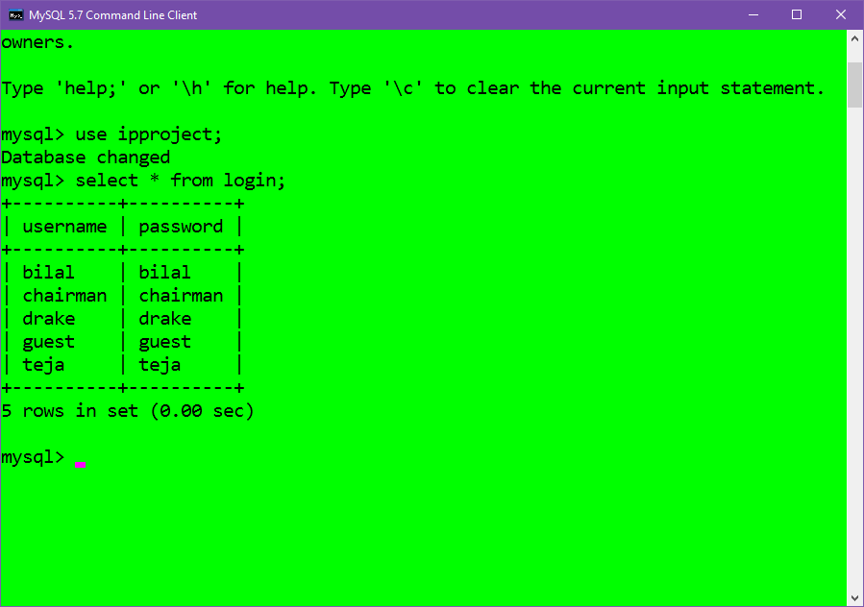

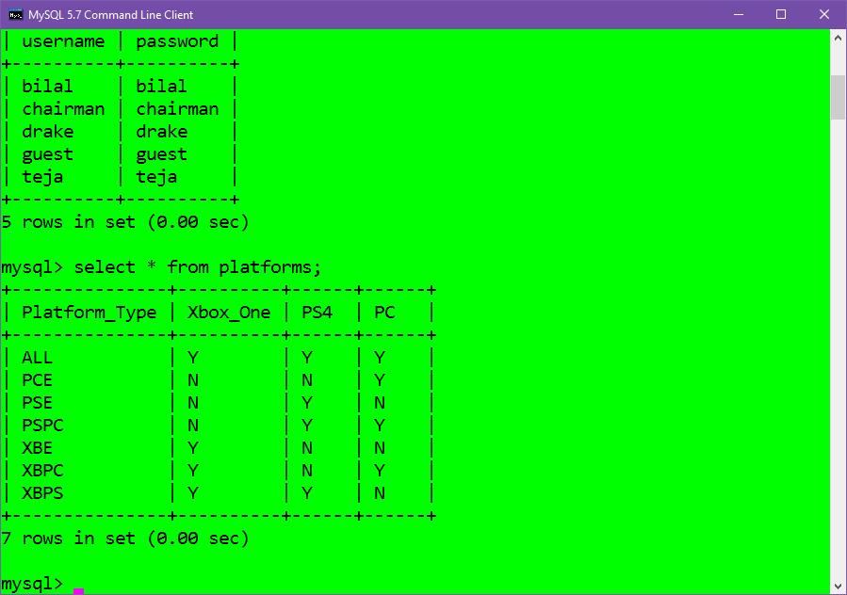

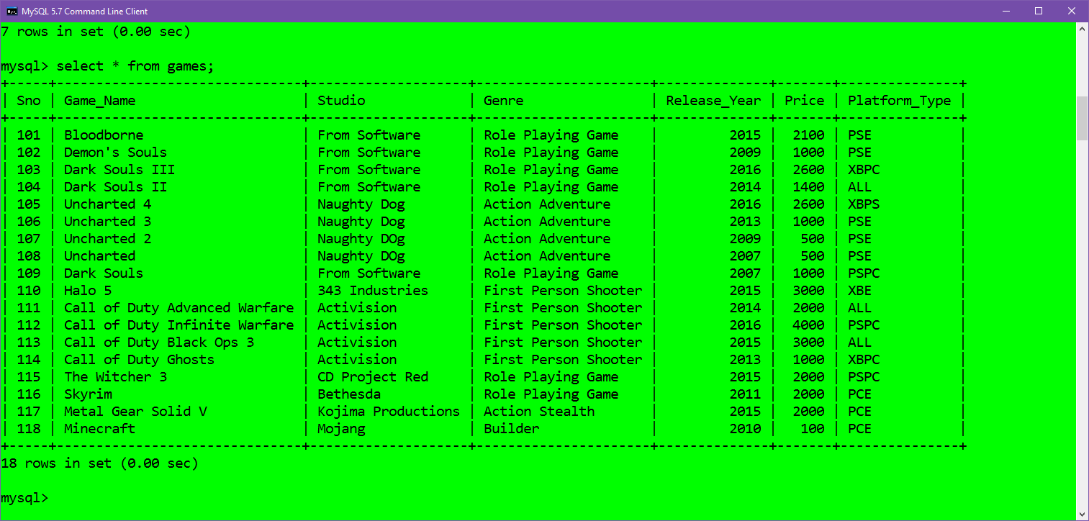

**Project Explorer**

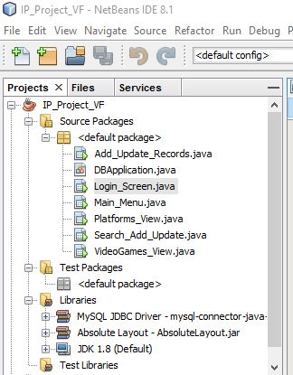

**DBApplication.java**

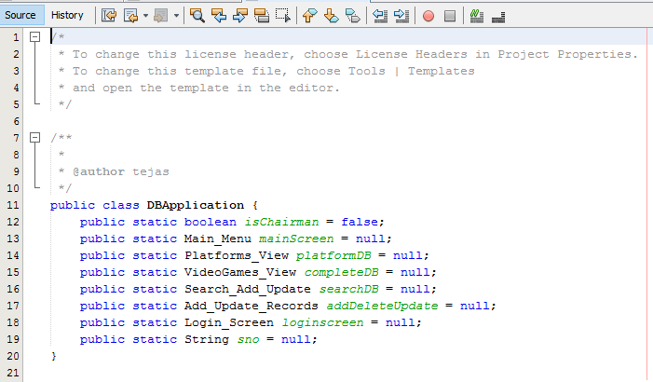

**Login_Screen.java**

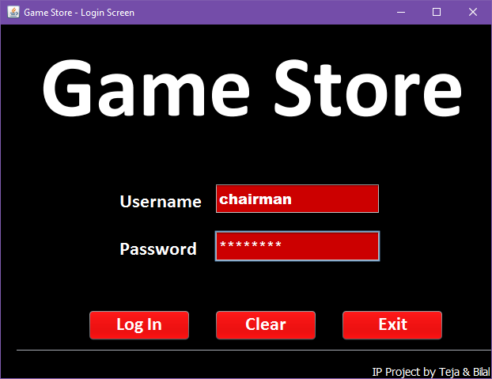

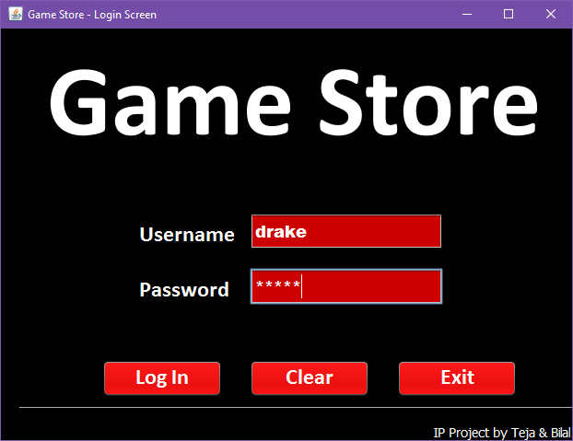

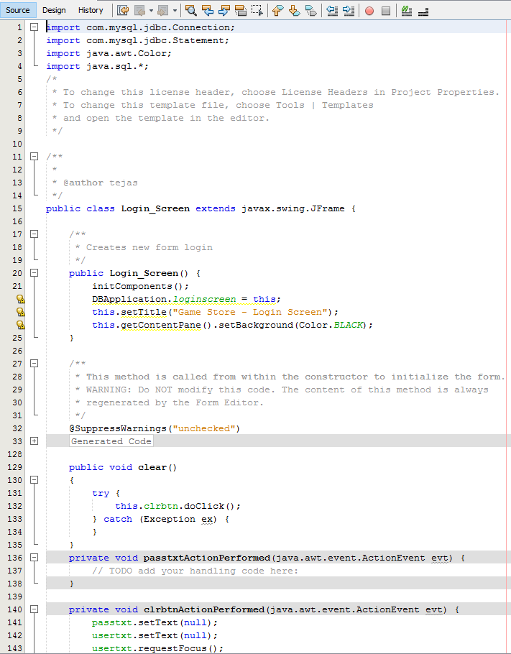



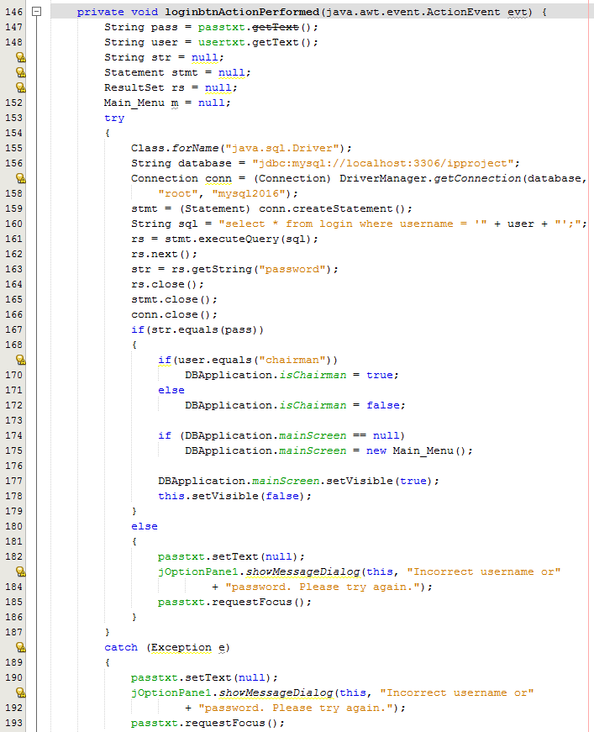

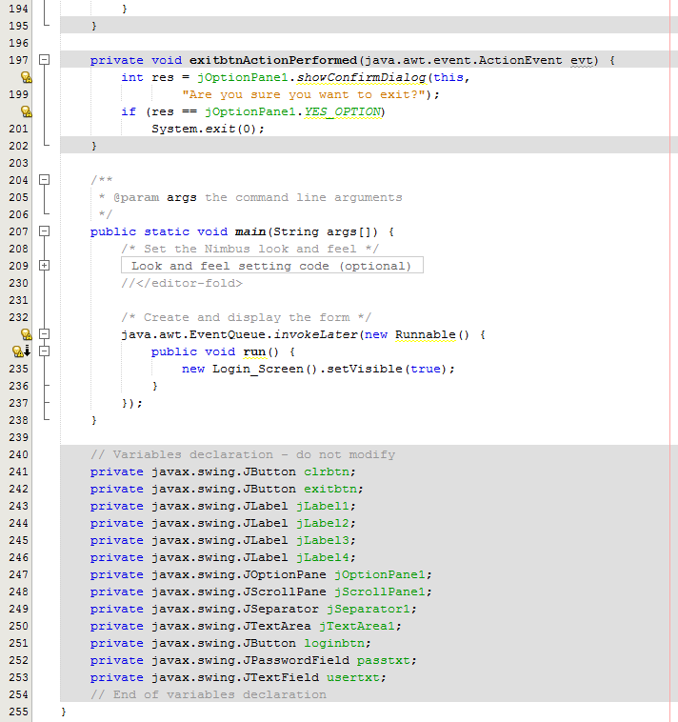

**Main_Menu.java**

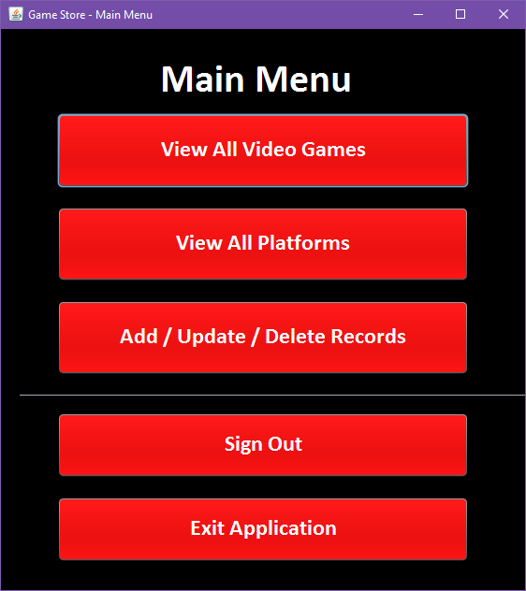

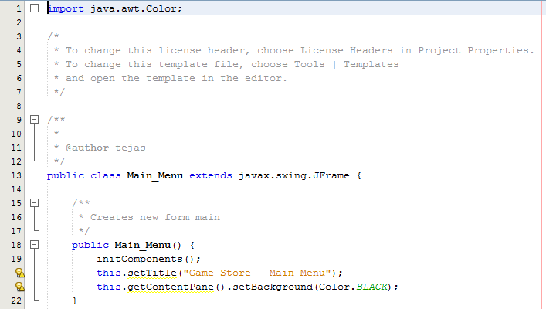

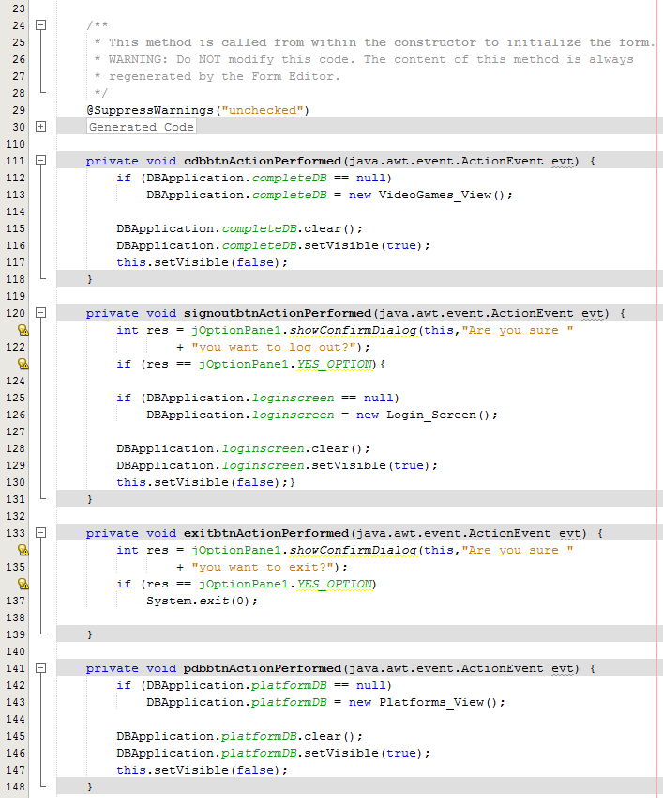

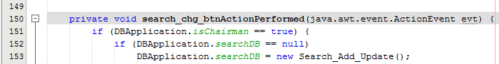

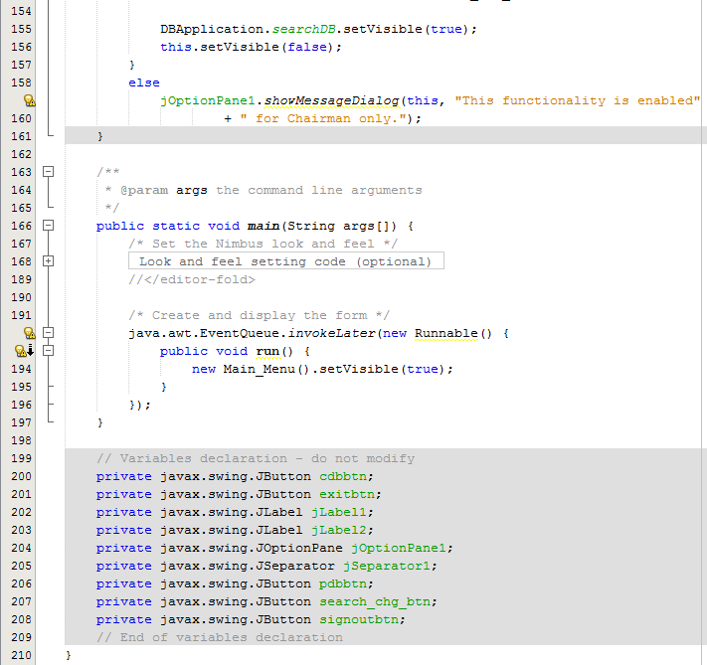

**VideoGames_View.java**

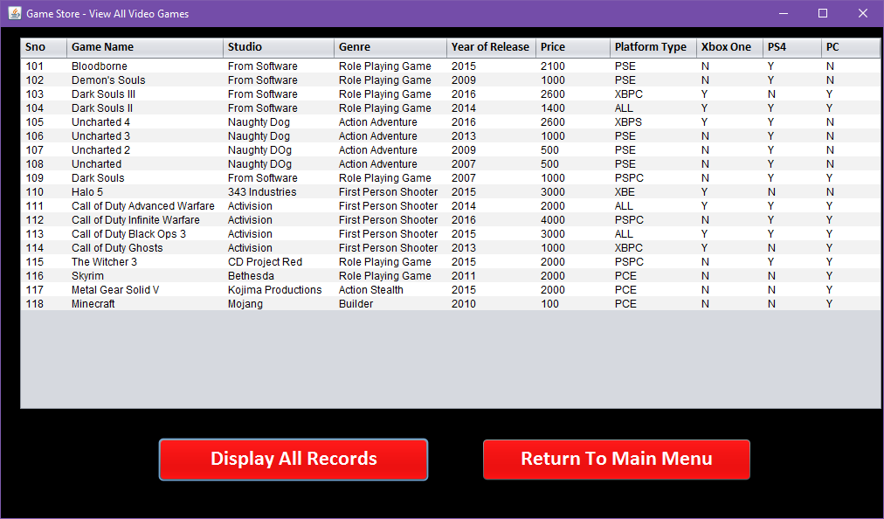

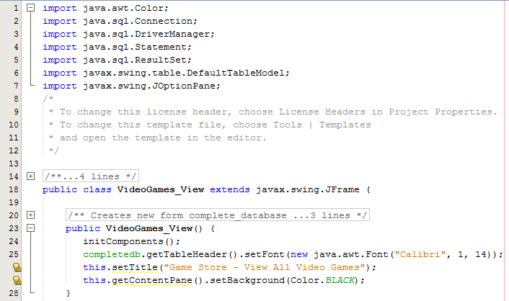

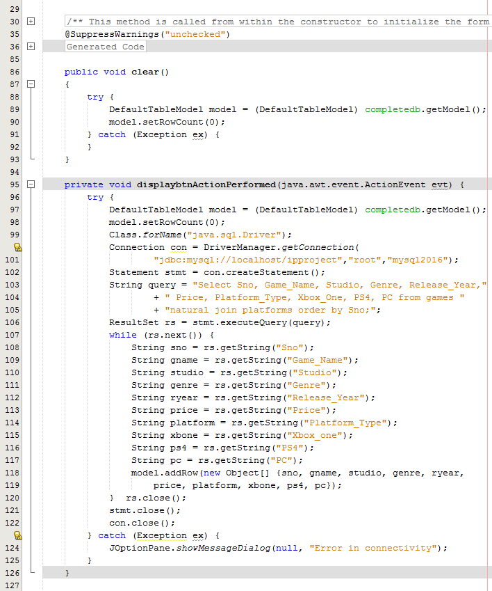

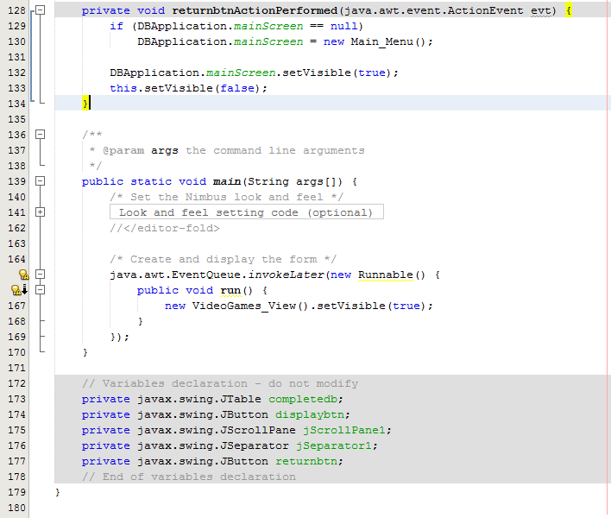

**Platforms_View.java**

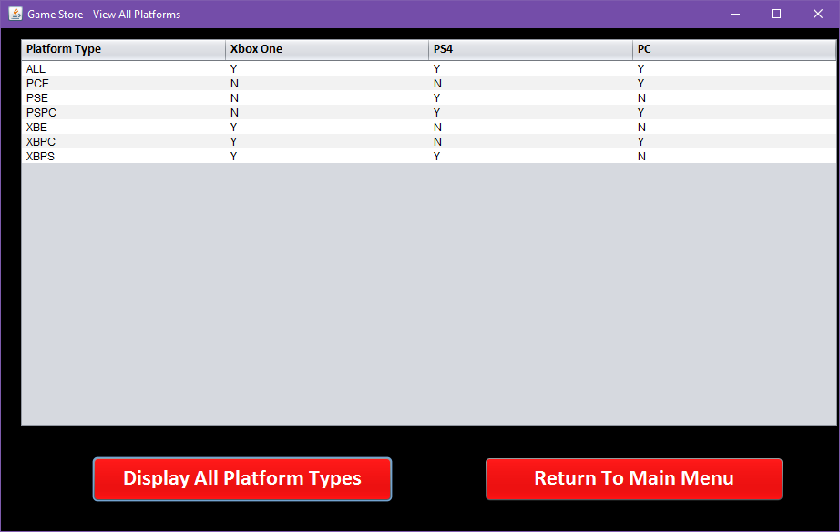

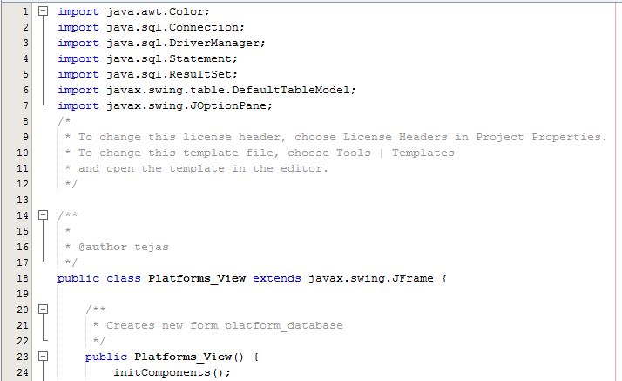

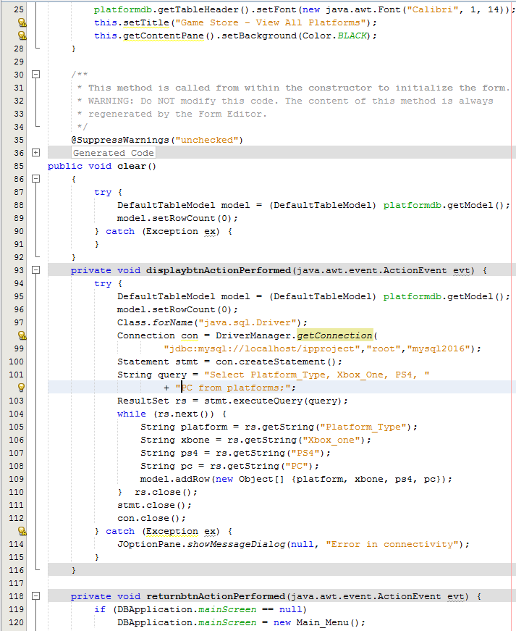

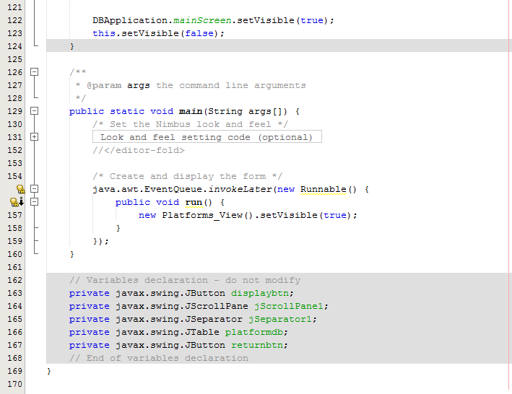

**Search/ Add / Update / Delete**

**View all records (no selection criteria provided)**

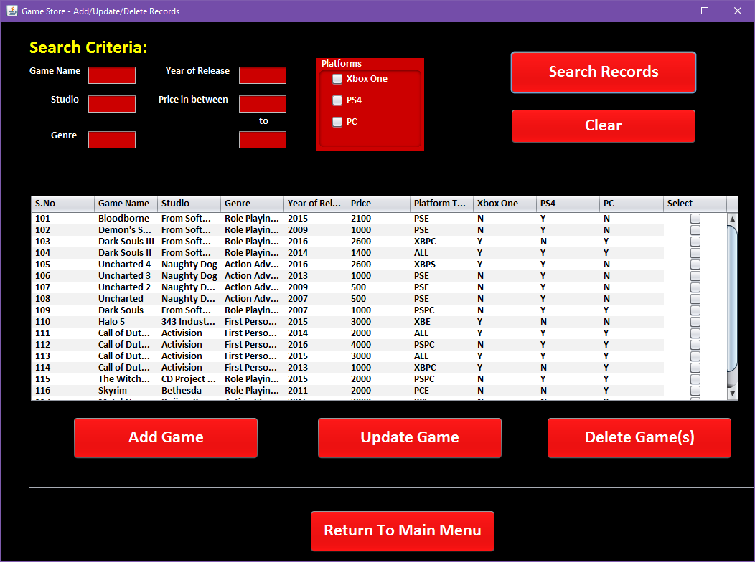

**Search for games based on Platforms**

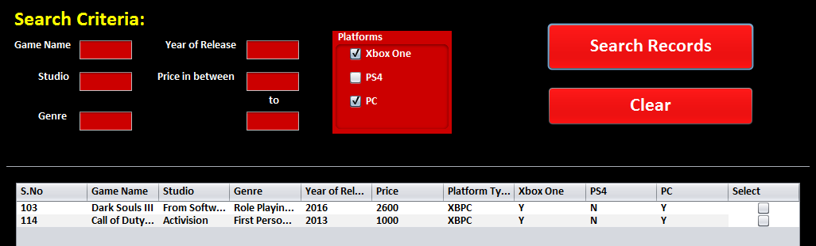

**Search for games based on Game Name**

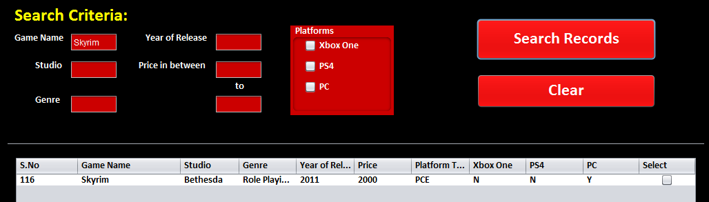

**Search for games based on** **Studio**

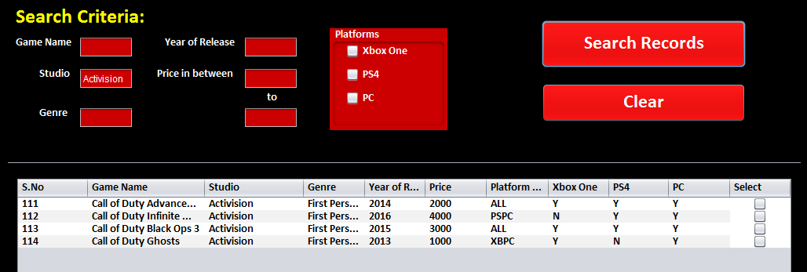

**Search for games based on** **Genre & Year**

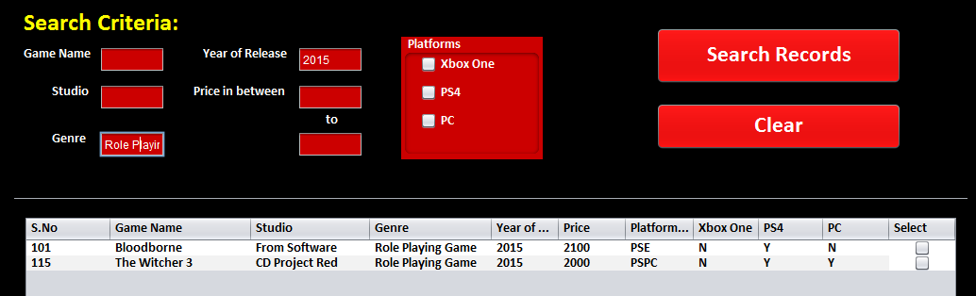

**Delete games (by selecting multiple rows)**

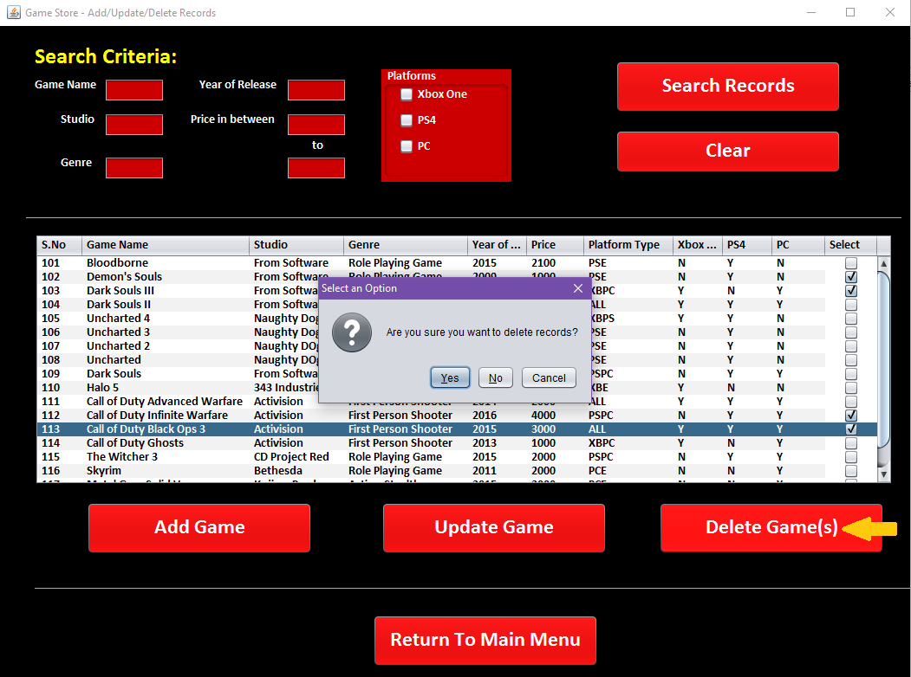

**Add Game**

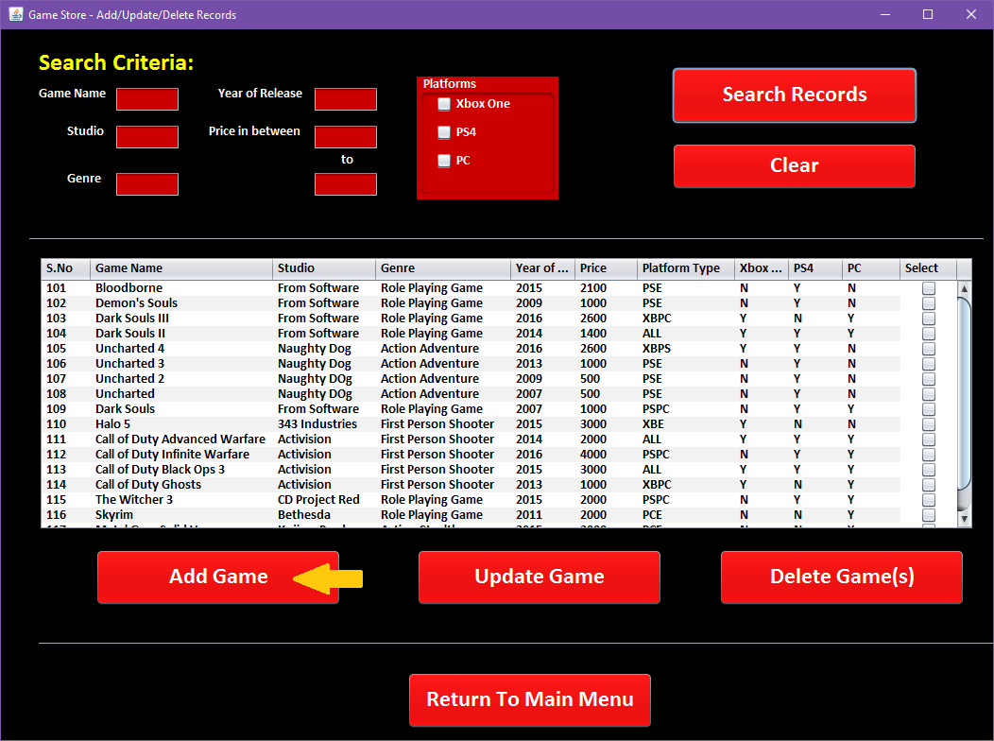

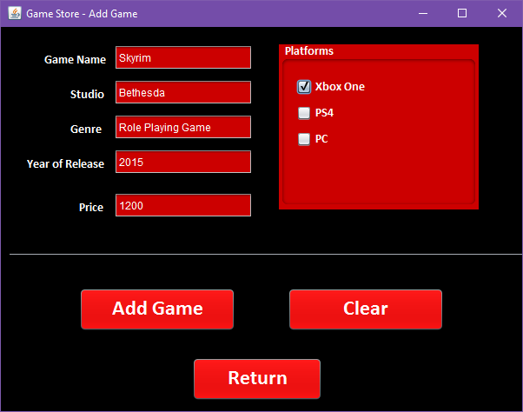

**Update Game**

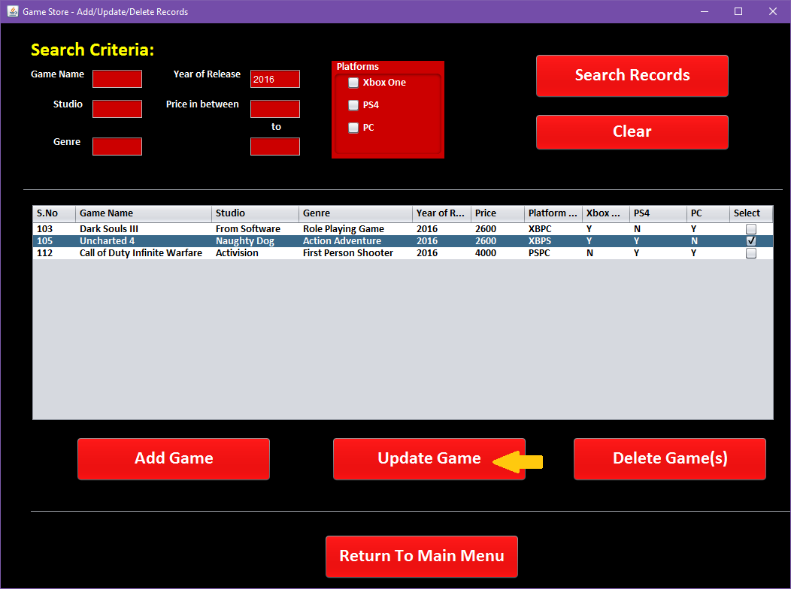

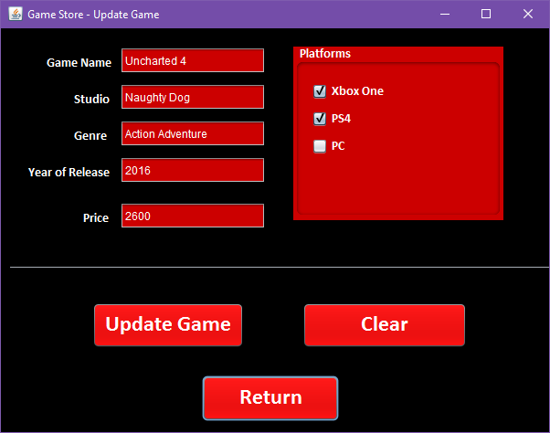

**Search_Update.java**

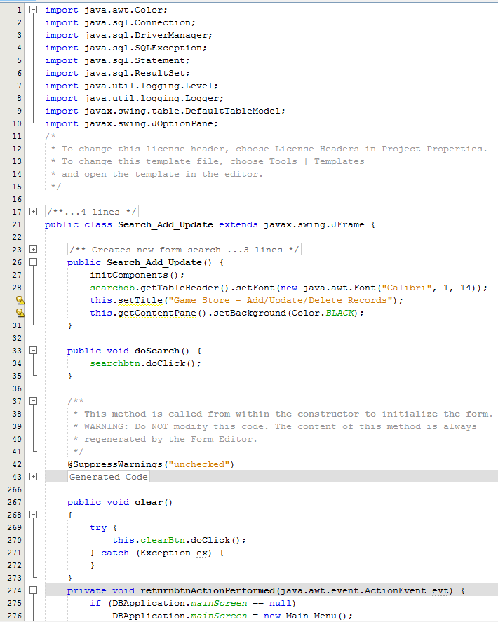

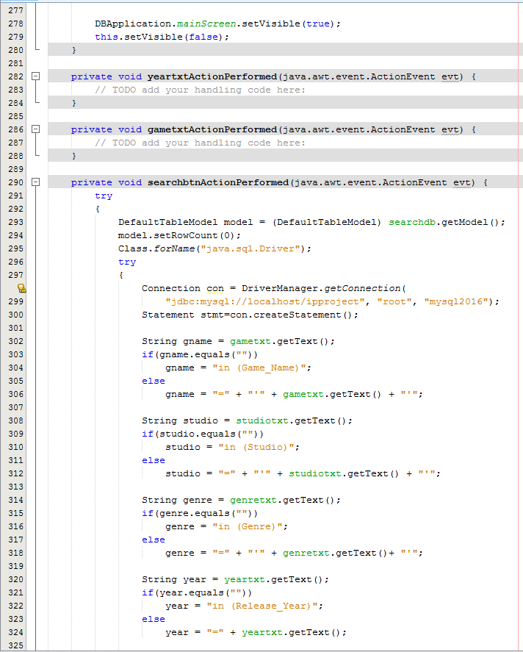

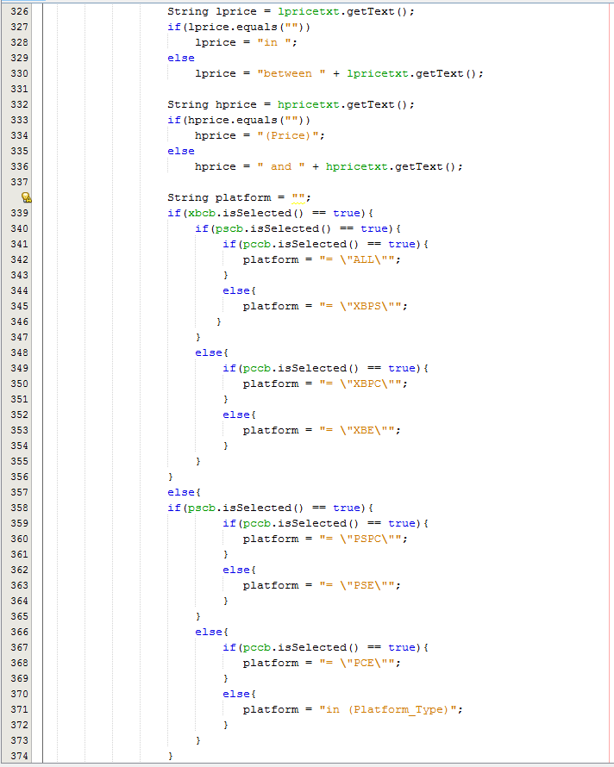

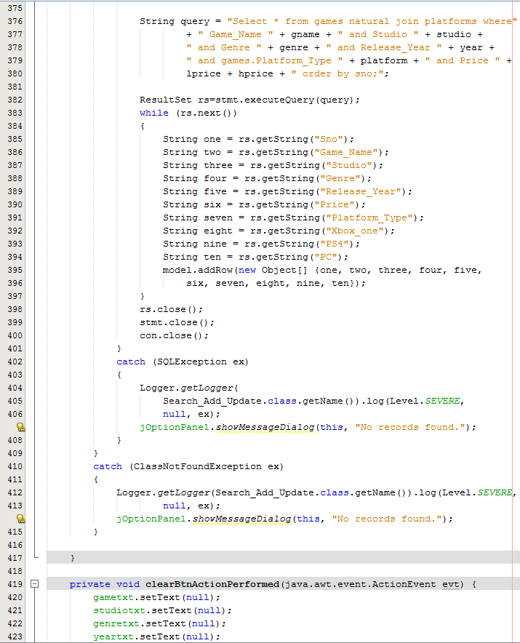

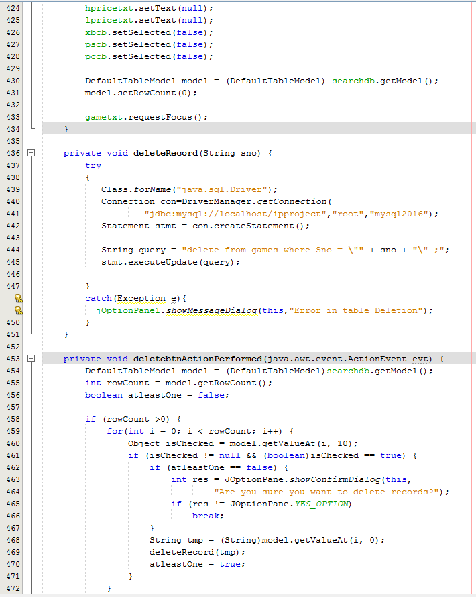

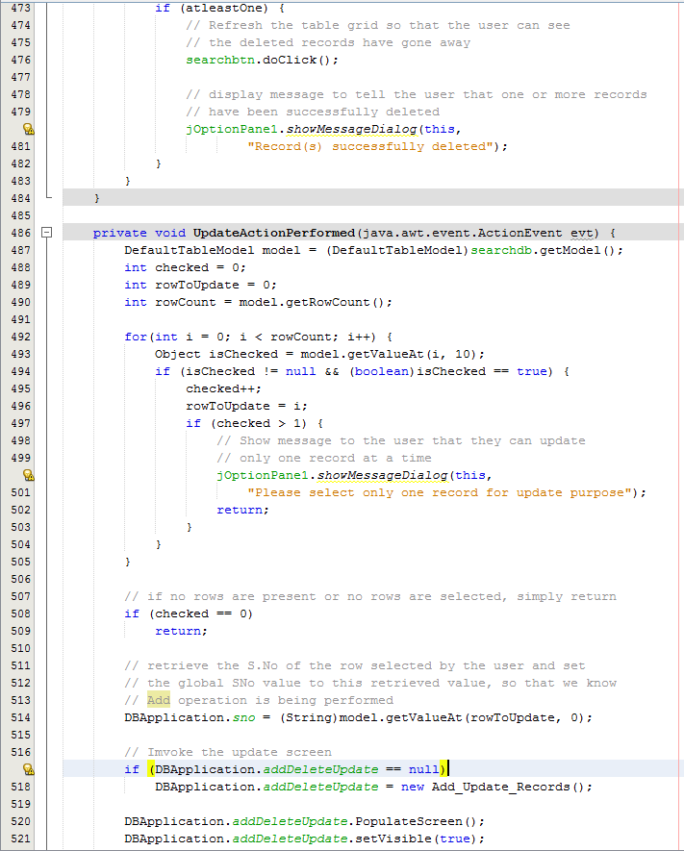



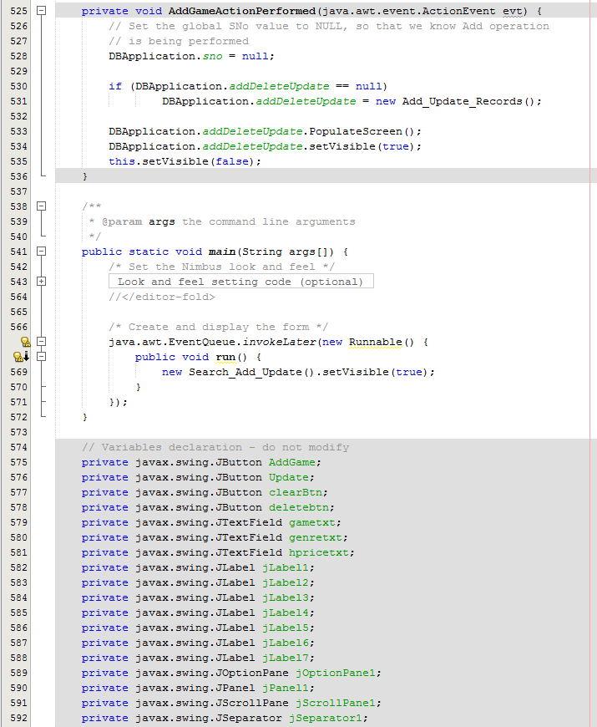

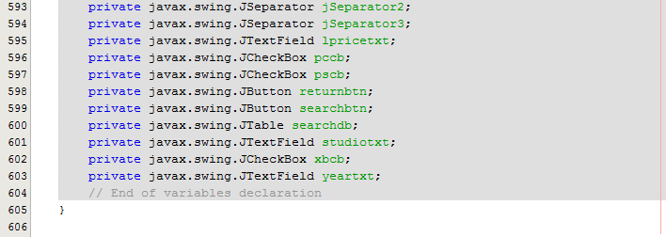

**Add_Update_Records.java**

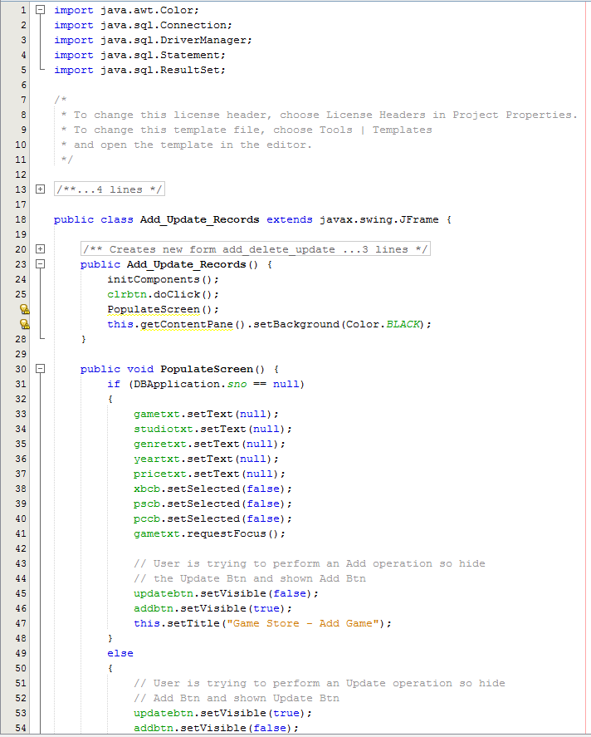

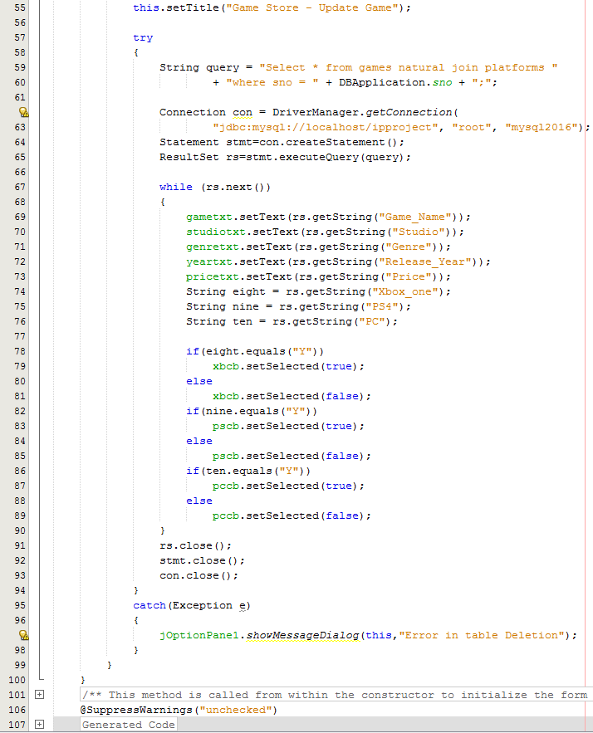

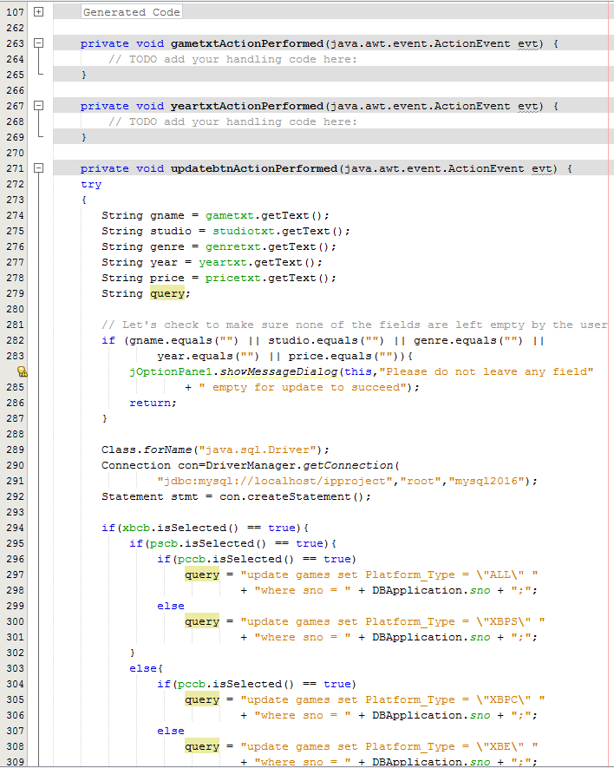

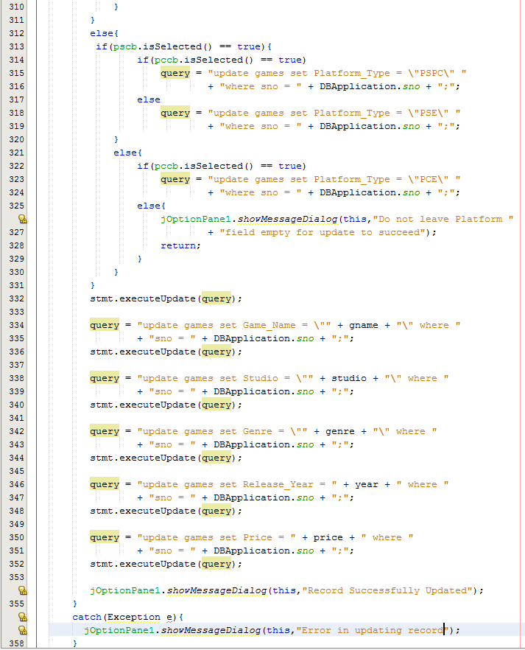



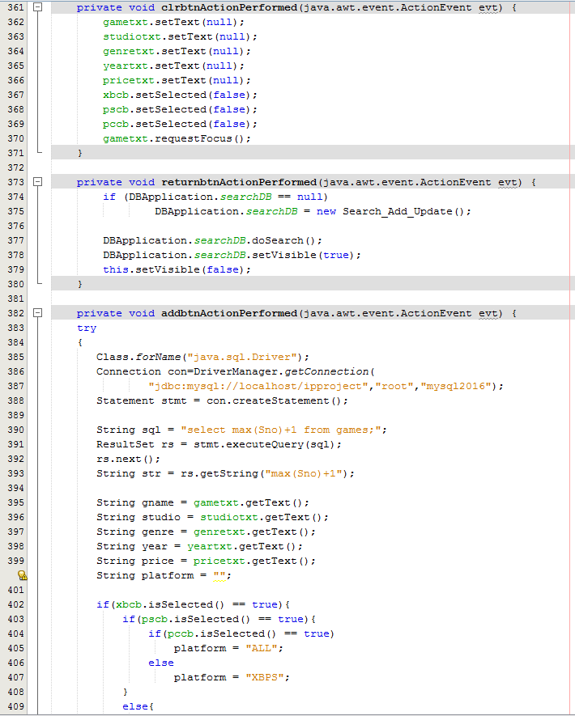

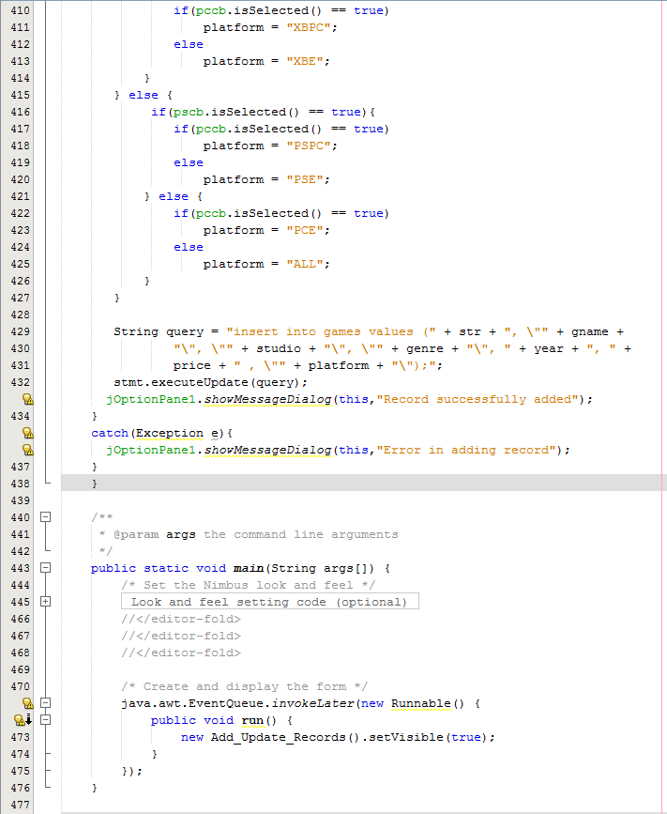

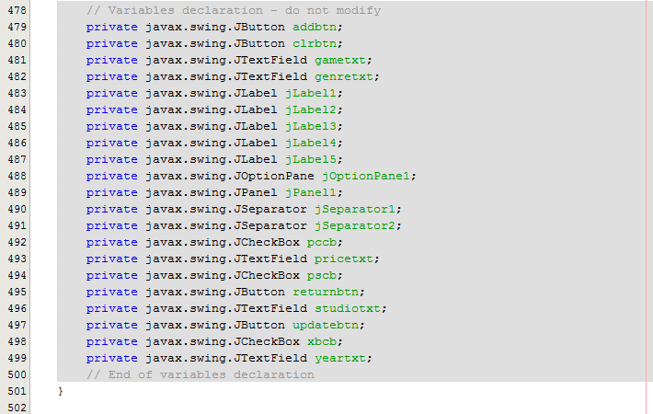

**BIBLIOGRAPHY**

* **Informatics Practices by Sumita Arora**
* **Move Fast with IP By Sumita Arora**
* **Internet**
  + **http://stackoverflow.com/**